

**St AGBIS SCHOOL**

**MANAGEMENT ACCOUNTS**

**for**

**AUTUMN TERM**

**for the**

**SPRING TERM FINANCE COMMITTEE**



**MANAGEMENT ACCOUNTS FOR AUTUMN AND FORECAST FOR CURRENT FY**





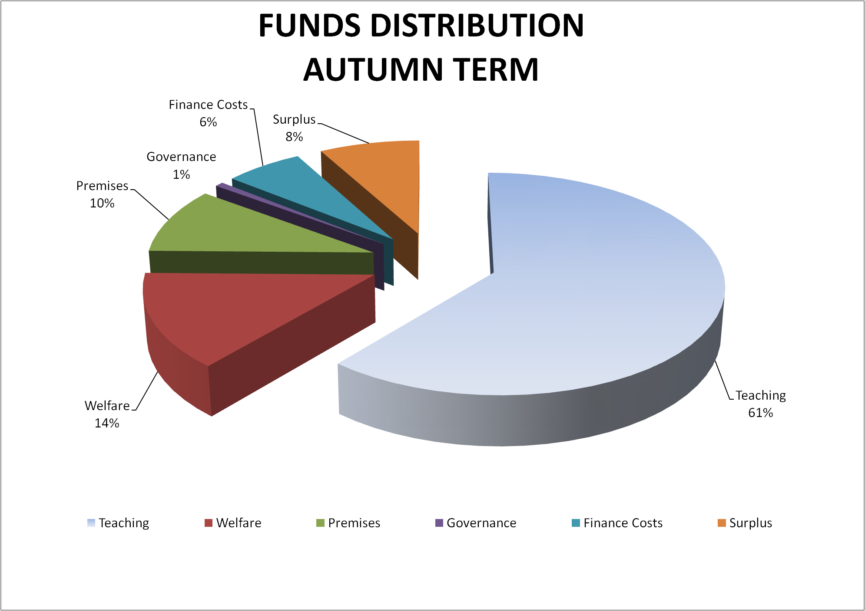

**ST AGBIS SCHOOL LTD**

**Remainder**

**Current Year**

**Year 2**

**Year 3**

**Year 4**

**Year 5**

**EOY**

**Spring**

**Summer**

**£'000**

**£'000**

**£'000**

**£'000**

**£'000**

**£'000**

**£'000**

**Surplus/Deficit for the Term/Year**

352

(286)

66

95

102

135

95

Add back Depreciation

64

106

170

330

333

347

352

Bank Loan

200

700

900

0

0

0

0

**Incoming resources**

**616**

**520**

**1,136**

**425**

**435**

**482**

**447**

**Major expenditure:**

New Teaching Block

(500)

(430)

(930)

(25)

New Teaching Block Loan Capital Repayments

0

(21)

(21)

(42)

0

0

0

Capital Projects (as Designated by Estates Committee)

(85)

(85)

(180)

(850)

(150)

(150)

**Total expenditure**

**(500)**

**(536)**

**(1,036)**

**(247)**

**(850)**

**(150)**

**(150)**

**Total Net Flow**

**116**

**(16)**

**100**

**178**

**(415)**

**332**

**297**

Working Capital

Creditors (movement) - Advance Fee Scheme

(20)

(20)

(40)

(41)

(26)

(6)

0

**Working Capital movement**

(20)

(20)

(40)

(41)

(26)

(6)

0

**TOTAL MOVEMENT**

**96**

**(36)**

**60**

**137**

**(441)**

**326**

**297**

Opening bank balances

**92**

188

92

152

289

(152)

174

Total movement

96

(36)

60

137

(441)

326

297

**CLOSING BANK BALANCES**

**188**

**152**

**152**

**289**

**(152)**

**174**

**471**

**Total authorised overdrat facility**

(200)

(200)

(200)

(200)

(200)

(200)

(200)

**COMMENTARY:**

1. The forecast surpluses are taken from the 5 year budget which has been approved by the Finance Committee and will be presented to the Board at the spring meeting.

2. With the new teaching block expected to complete at Easter, all stage payments will be due over the spring and summer terms except for theretainer which will be due payment next summer.

3. Capital repayments of the loan for the new block will commence in the summer term and will represent capital expendiure for the duration of the loan (10 years)

4. The Finance Committee has endorsed the recommendations of the Estate's committee for expenditure of:

£85k this summer for the new pool heaters

£180k in Year 2, for a new pavilion for the lower field

£850k for the next major project in Year 3 (new Science Labs)

£150k in Year 4 for the Nursery extension

£150k in Year 5 for a project tbc

5. If the initial estimates are correct then this profile should allow for the planned capital expenditure without the need for a further loan

**CASH FLOW FORECAST**

**Current Year**

**BY TERM**